Introduction to Document
- This document will contain visual designs, algorithm designs and data requirements designs.
Visual Designs
- Sitemap
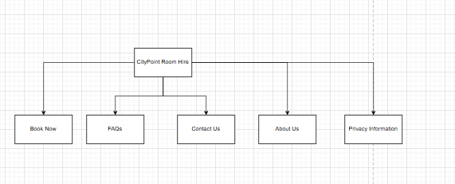
- Wireframe Designs for each page
- Annotate each design with the following
  - Colour Scheme
  - Font Style
  - Font Size
  - Why are you making these decisions? Keep in mind the target audience
Algorithm Design
- Introduction to the complex problems you will be writing algorithms for
- Login
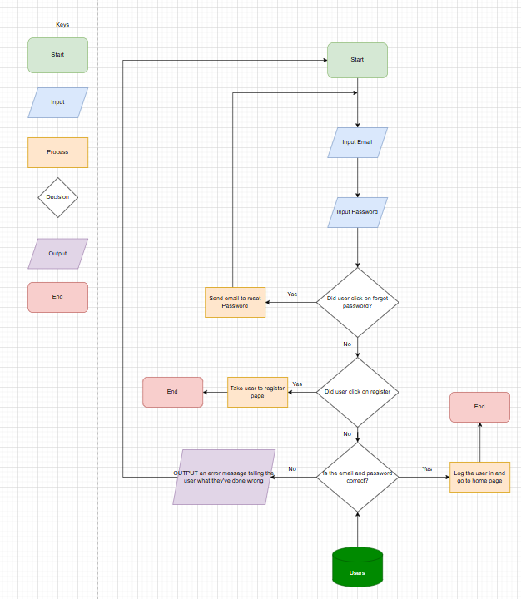
Log in Flowchart
- Register
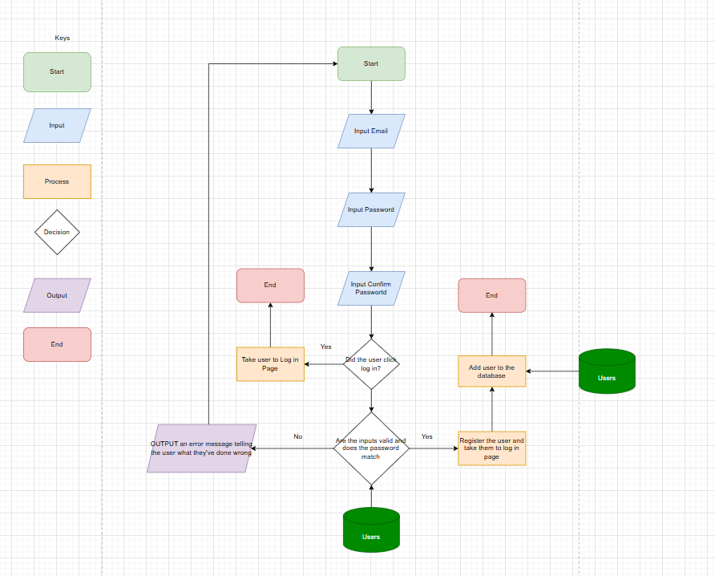
Register Flowchart
- Create Booking
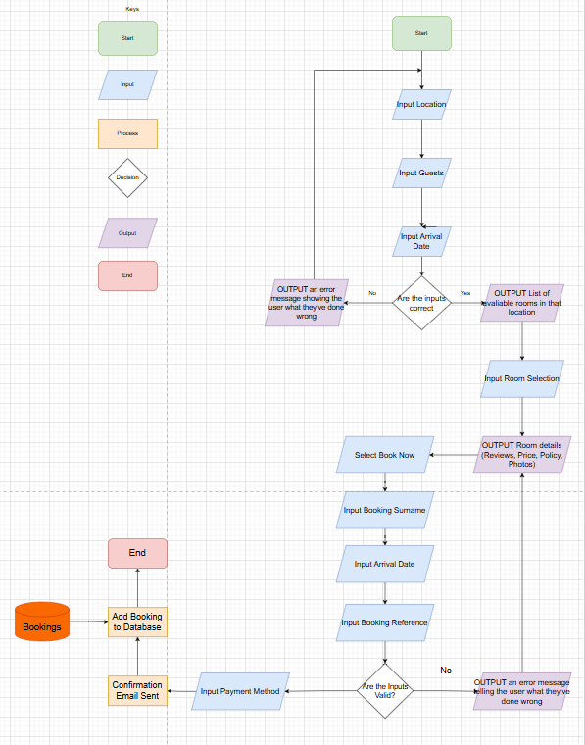
Create Booking Flowchart
- View/Amend Booking
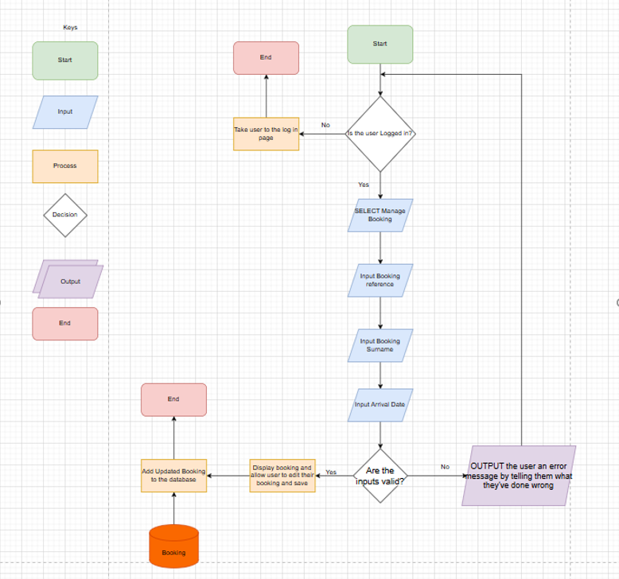
View/Amend Booking Flowchart
- Admin dashboard/login
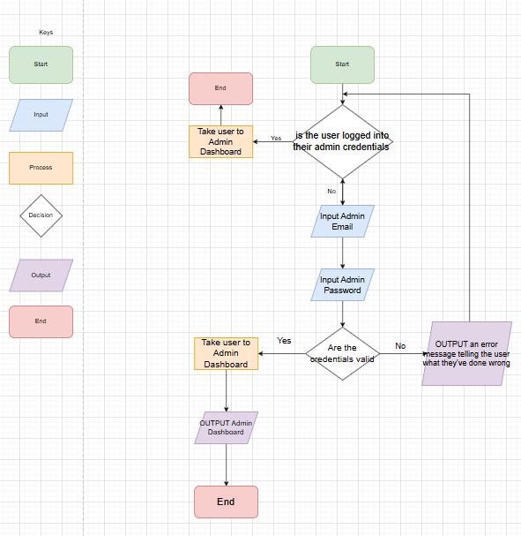
Admin Flowchart
- The pseudocode or flowcharts for each problem
  - Minimum of 3
  - Maximum of 5
  - Need to explain what the algorithm is doing and the process of it
Data Requirements Design
- 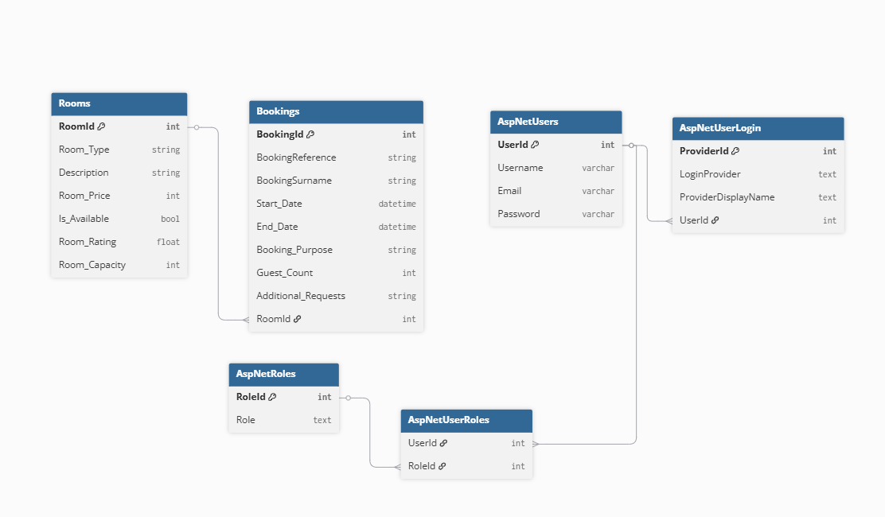
Data Dictionary
Rooms

 | Data Type | Required | Default | Validation | Primary/Foreign Key
RoomId
Room_Type

Test Strategy
- Make sure to fill out the template they gave you and resave it as mentioned
Date of test |  | Component to be tested | Type of test to be carried out | Prerequisites and dependencies
Can leave this blank | Every page, button, form, validation and more |  | Acceptance testing, alpha testing, beta testing, black box testing and white box testing | What needs to be completed before the test can be run

